Phase 1: Planning & Design

Physical Topology

The Single Switch Cabinet (Rack):
    - U1–U4 (Top): 4 × D-Link Patch Panels (Grouped together at the top to aggregate incoming PC lines safely).
    - U5–U6 (Middle): 2 × Cisco Catalyst 3560 Switches (Placed directly under the patch panels for short, clean patch cord routing).
    - U7–U8 (Bottom): 2 × Cisco ISR 4331 Routers (Placed at the bottom due to heavier weight and separate power requirements).
  - The Device Connections: 10 PCs sit externally. Their solid-core cables run directly into the back of the 4 patch panels inside the cabinet.

Logical Topology & VLAN Infrastructure
To accommodate 10 PCs across 2 switches and 2 routers, the network should be segmented logically into departmental VLANs to demonstrate routing capability.
  - VLAN 10 (Engineering / Management): PCs 1–4 (Connected to Switch 1)
  - VLAN 20 (Sales / Operations): PCs 5–8 (Connected to Switch 2)
  - VLAN 30 (Server / Admin): PCs 9–10 (Connected to Switch 1 or 2)
- 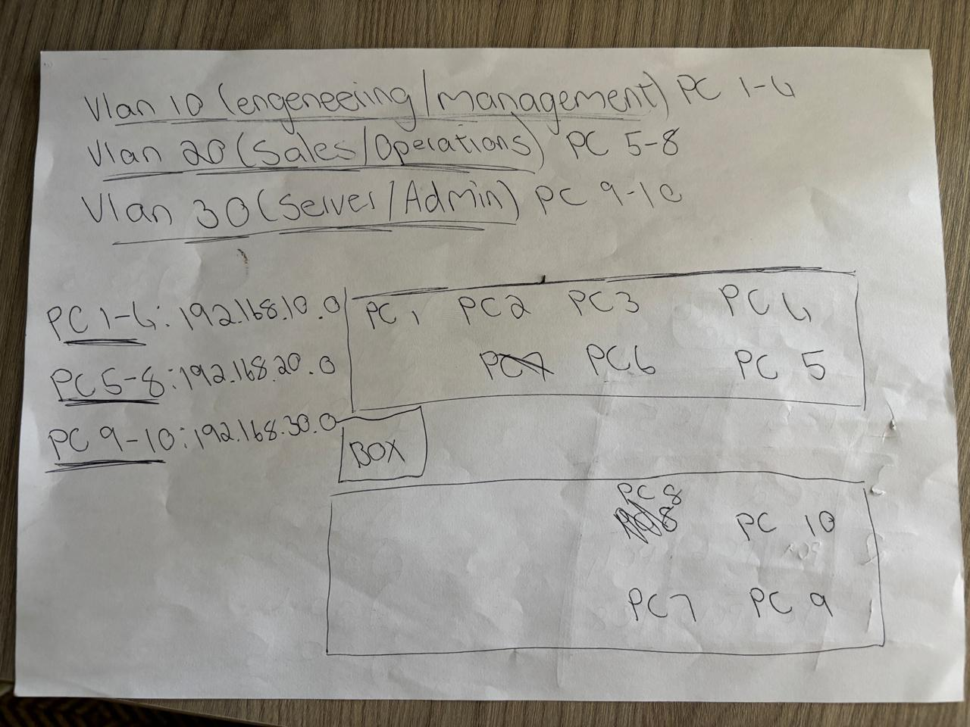

  - Native/Management VLAN 99: For Switches and Routers IP addresses.

IP Address Planning
Using a private Class C subnet space (192.168.0.0/24), divided using VLSM:

  - VLAN 10 Subnet: 192.168.10.0/26 (Gateway: .1)
  - VLAN 20 Subnet: 192.168.20.0/26 (Gateway: .1)
  - VLAN 30 Subnet: 192.168.30.0/26 (Gateway: .1)
  - Management VLAN 99: 192.168.99.0/24
  - Router-to-Router Link: 10.0.0.0/30 (R1: .1, R2: .2)

Phase 2: Hardware Installation & Cabling
- Install Switch Cabinet: Securely mount the rack enclosure. Ensure grounding cables are bonded to the cabinet chassis.
- Install Patch Panels: Screw all 4 D-Link patch panels into the top rack units (U1–U4).

Terminate Internal Cable Runs:
  - Route the raw CAT6 cables coming from the 10 PC stations into the cabinet.
  - Pull them to the back side of the patch panels.
  - Use the insertion (punch-down) tool to map the wires directly to the T568B color-coded blocks.
  - Note: Because outlets/faceplates were removed, the PC side of the cables must be

punched down into loose CAT6 keystone jacks sitting at each desk.
- Test Cabling: Use a hardware cable continuity tester on the punched-down lines to ensure no split pairs or shorts exist before powering up electronics.

Phase 3: Device Initialization & Layer 2 Config
- Physical Console Access: Connect a PC running PuTTY to the Cisco devices using the provided Console cables (RJ45-to-DB9 or USB-to-RJ45) plugged into the device's Console port.

Basic Configuration (Switches & Routers):
Router(config)# hostname R1
R1(config)# enable secret YourStrongPassword R1(config)# line vty 0 4
R1(config-line)# password YourVtyPassword R1(config-line)# login

Switch Management Interfaces:
SW1(config)# vlan 99
SW1(config-vlan)# name Management SW1(config)# interface vlan 99
SW1(config-if)# ip address 192.168.99.10 255.255.255.0 SW1(config-if)# no shutdown

Configure VLANs & Access Ports:
SW1(config)# vlan 10
SW1(config-vlan)# name Engineering SW1(config)# interface range fa0/1 - 4 SW1(config-if-range)# switchport mode access SW1(config-if-range)# switchport access vlan 10

- Trunking between Switches: Configure Inter-Switch Links (ISL/802.1Q) to allow VLAN traffic to traverse both Catalyst 3560s.

Phase 4: Layer 3 Configuration & Routing
- Configure Router Interfaces: Assign IPs to the physical interfaces connecting the two Cisco ISR4331 routers together.
- Inter-VLAN Routing (Router-on-a-Stick): Connect a trunk port from Switch 1 to Router 1's GigabitEthernet interface. Create sub-interfaces on the router to act as defaults gateways for the PCs:
R1(config)# interface gi0/0/0.10 R1(config-subif)# encapsulation dot1Q 10
R1(config-subif)# ip address 192.168.10.1 255.255.255.192

- Configure Routing Protocols: Set up static routing or OSPF between Router 1 and Router 2 so networks on Switch 1 can communicate with networks on Switch 2.
- Verify Routing Tables: Run show ip route via PuTTY to ensure all subnets are visible.

Phase 5: Network Printers (Skipped / Simulated)

Status: Omitted per instructions.
  - Alternative Action: If the instructor requires verification of this phase despite missing hardware, assign an unused IP address (e.g., 192.168.30.50) to a loopback interface on a switch or router to act as a "Virtual Printer," then verify that all VLANs can successfully ping it.

Phase 6: Testing & Troubleshooting
- Verify Connectivity: Ping from a PC in VLAN 10 to a PC in VLAN 20.
- Verify VLAN Functionality: Use show vlan brief on the switches to confirm ports are grouped correctly.
- Resolve Instructor Faults: Common simulated faults to look out for via PuTTY command line:
  - Wrong VLAN Assignment: Fixed using switchport access vlan X.
  - Native VLAN Mismatch: Fixed by matching native IDs on both ends of a trunk link.
  - Subnet Mask Mismatch: Check PC IP configurations vs the Router sub-interface gateway.

Phase 7: Documentation
Produce a final network book containing:

- Completed Visio/Packet Tracer Logical Diagram.
- High-level Cabinet Rack Layout map (Physical topology).
- Master IP Addressing Matrix table (listing every PC, Switch, Router interface, and functional gateway).
- Text file backups of the running configurations (show running-config) saved directly from the PuTTY session logs.

